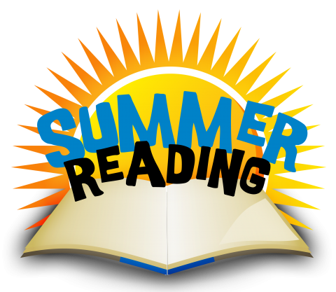
Our family participated in the 2018 Summer Reading program. These are the books we read:
Title: Author:
__________________ _________________
__________________ _________________
__________________ _________________
__________________ _________________
__________________ _________________
__________________ _________________
__________________ _________________
__________________ _________________
Please return this completed pamphlet to your child’s
new teacher in September!

Child’s Name_____________________________
Parent/Guardian
Signature__________________________

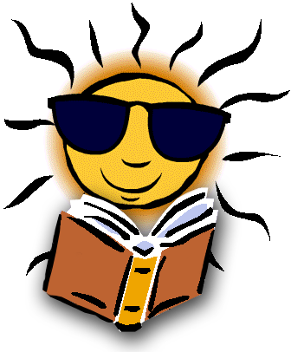
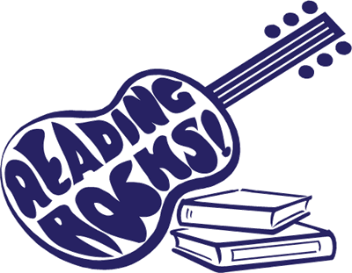
Half Hollow Hills
Summer Reading
2018

HAVE FUN READING!
The idea of this program is to promote a love for reading! We are partnering with the NYS Libraries’ Summer Reading theme “Reading Rocks” in our summer reading adventure.

Here’s how it works! Using the attached grids, have fun completing at least 6 activities. Submit at least one artifact (a picture of one completed activity) by emailing it to the following email address:

pasummerreading@hhh.k12.ny.us

Please be sure to include your child’s name, grade, book title and which activity you have chosen.

“Summer reading is about holding a book (or an e-reader) in your hands and kicking off your shoes and staying up much too late to keep reading. It is about rushing through one book to get to the next or lingering as long as you want. It is about vicarious experiences that let us become a girl in an attic, a boy in the wilderness, or a kite-runner in a faraway land. That type of reading begins with personal choice.”
- Kylene Beers 2014
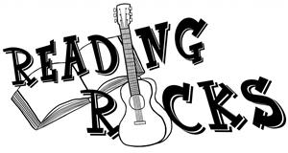
Complete three reading activities from this grid. Place a sticker on each reading activity you chose! Feel free to use the grade level book suggestions to choose new books to explore!

Read a book and create a song about the story. Sing the song to a friend of family member. | Read a recipe with a parent and make dinner or dessert together. | Read a biography. | Read a Historical Fiction story.
Read a book about the future. | Read a book that was turned into a movie. | Read a book about geology, rocks, gems, or the environment. | Read a Fantasy story.
Read in your swimsuit. | Read a Newberry or Caldecott Award Book Winner. | Read a magazine in a new place. | Read about a place that you have never visited.
Read a book about the past. | Read with your pet and take a picture. | Read a Graphic Novel. | Read a book outside.
Read a book on myON. | Listen to an audio book. | Read a book from the year that you were born. | Read a book in a new series.
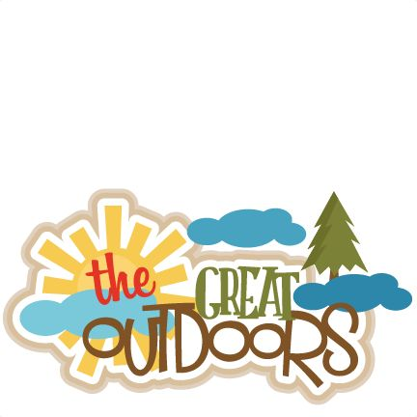

Get Outside and Have Fun!
Complete three activities from this grid. This summer, we want you to get outside, try new things, and have fun! Place a sticker on each activity you complete.

Play at a playground. | Screen Free Challenge! Turn off all electronics for a whole day and get outside! | Explore a new park near your house with a  family member.
Play a board game with a friend. | Attend a community event at the library with a friend. | Read directions and then make slime.
Lego Challenge: Design and build your dream bedroom, or another creative structure. | Make musical instruments out of recycled materials. | Build a fort with friends outside.
