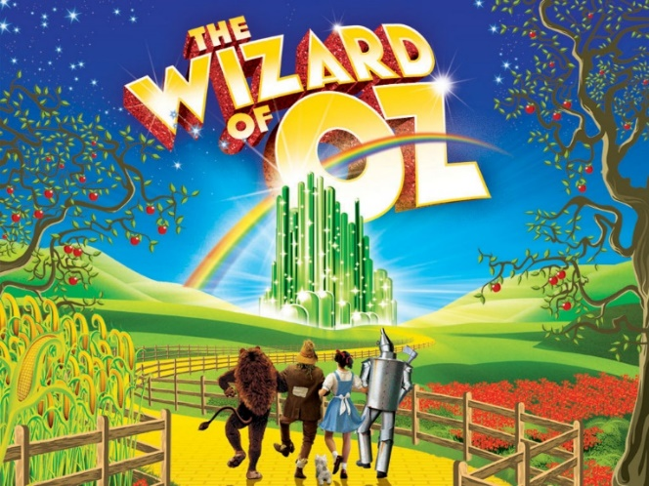
CW DRAMA CLUB T-SHIRT ORDER FORM
Please complete the order form below
Make check or money order payable to
Candlewood Middle School Drama Club
$15 per t-shirt
Please return in an envelope
(Include child’s name on envelope)
To Cindy DeMeo or Angela Duarte in the main office
STUDENT NAME: ________________________________________________________________
PHONE #: _______________________________________________________________________
EMAIL __________________________________________________________________________
SELECT SIZE QUANTITY PRICE
CHILD LARGE
ADULT SMALL
ADULT MEDIUM
ADULT LARGE
ADULT X-LARGE
ADUILT XX-LARGE (add $2.00)

For Office Use Only: Check # Money Order # By:

